**REACT UDEMY**

**React is using virtual DOM which means that only the component that needs to be updated is affected. Which means only that component is re-rendered.**

[**https://ant.design/**](https://ant.design/) **Very useful components**

**(032 Import and export statement)**

**When calling a component, always open and close < *ComponentName* />**

**If we want to export a component, we write at the end of the file:**

**export default *nameOfComponent\***

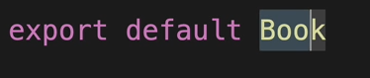

**If we want to export a variable, we write at the beginning of the file, where we declare the variable:**

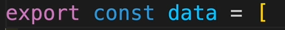

**When we import those:**

1. **We import the variable with the exact same name**
2. **We import the component with any name we want ( that’s what the word default does) as long as we import from the correct file name**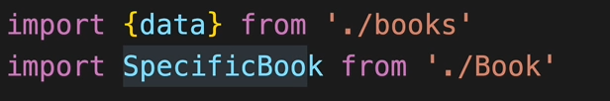

**(018 First Component in Detail)**

**Stateless Functional Component**

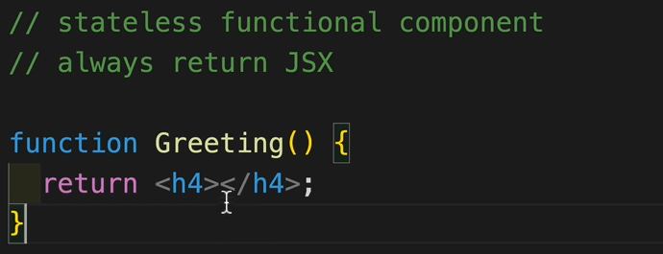

* **They are also called Dumb Components because at the moment, it doesn’t have a STATE**
* **They always have to return something, even if that something is An Empty HTML**

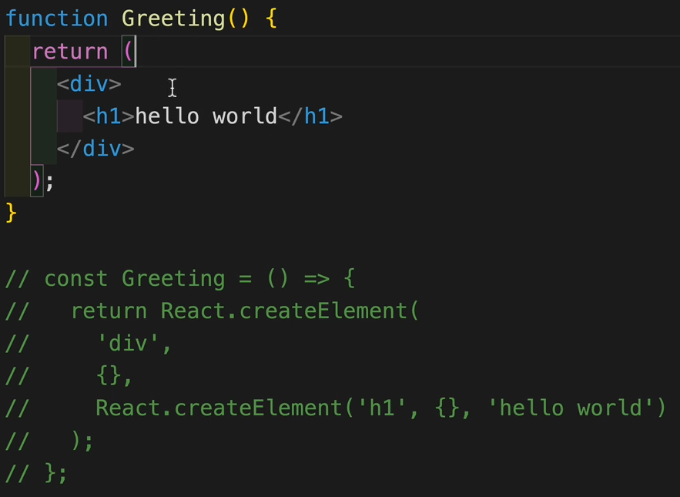

**The two functions are equivalent. This picture purely wants to demonstrate how the React.createElement function is called for each html line of code written. For each line of code, the React.createElement is called “under the hood”.**

***Video: 019 JSX Rules***

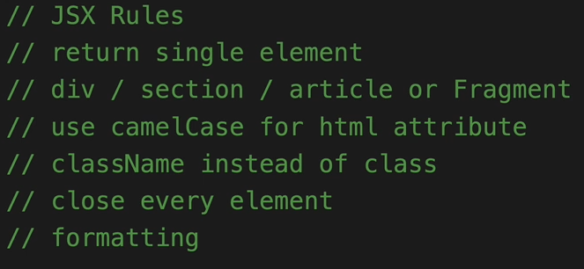

**Rule1:**

* **We can enclose everything in a react fragment ( <> </>) and that way we will not even create an unnecessary div**

**Parentheses for the return of a function**

**When returning a function, we can use or omit placing the return value in open brackets.**

**If we omit the parenthesis, then the opening tag of the return value has to be on the same line as the return keyword like this.** 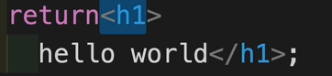

**If we use the paranthesis, we don’t have to worry about placing the return value on the same line.**

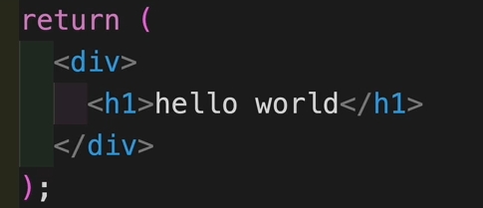

**(From 020 Nested Components and Tools)**

**Instead of writing like this:**

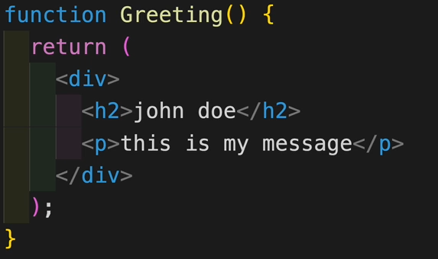

**We can create more components and nest them in another component like this**

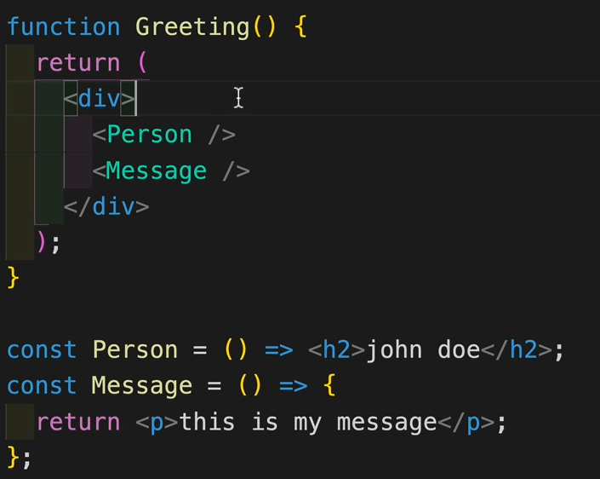

**As a sidenote, the first component is an arrow function with an IMPLICIT RETURN, the second one is with an EXPLICIT RETURN, just to show both methods work.**

**(FROM 023 JSX – CSS)**

**Adding CSS directly to code in react.**

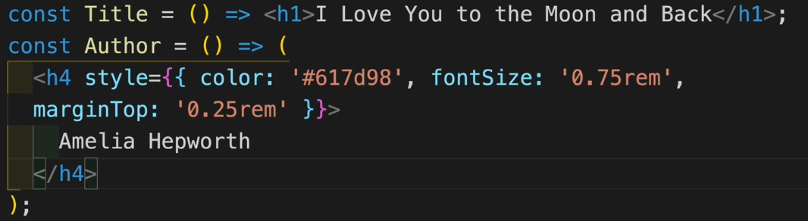

**Formatting css tags for only one specific component**

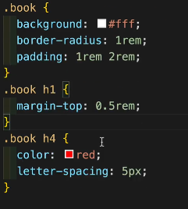

**(From 024 JSX – Javascript)**

**From this video, at 06:00, you can see where the Printable Keyboard Cheatsheet is for Visual Studio.**

**Using variables inside the react.**

**Let’s change this header**



**Into a variable**



**And calling the variable where the original h1 was placed**



**We can also call methods on variables, because these methods also return a value**

** Will work**

**One thing to note, is that**

**IF YOU WRITE JAVASCRIPT IN THE JSX, IT MUST RETURN A VALUE.**

**We cannot write a statement like**

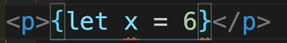 **Will return an error**

**A statement that returns a value works even if it represents a calculation**

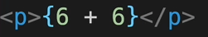 **Will work**

**( 025 Props)**

**Call an image like this:**

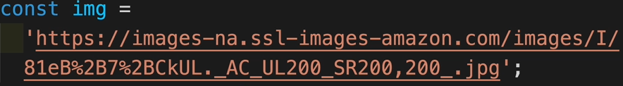

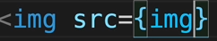

**When referring to props, they are short for properties because they represent the properties passed to our object.**

**If we have our object called Book and it has props as its parameter**



**Our object renders variables or its props**

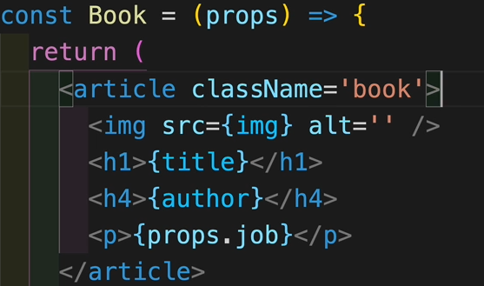

**Wherever that object is called, we can give values to those props, one or more**

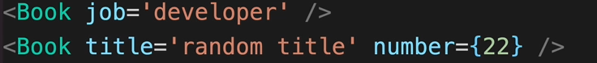

**For the first call of the object, it has the prop job as ‘developer’ so when it is rendered, the <h4>{props.job} </h4> will render the word developer.**

**Keep in mind that the 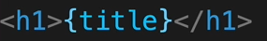 and the prop ‘title’ visible in the second call of the book object do not refer to the same entity. The first is a global variable, the second is a prop of the second book object.**

**So we have the object book**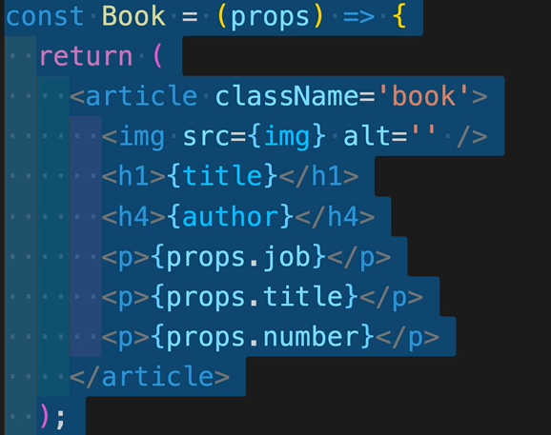

**And this section where 2 book components are called**

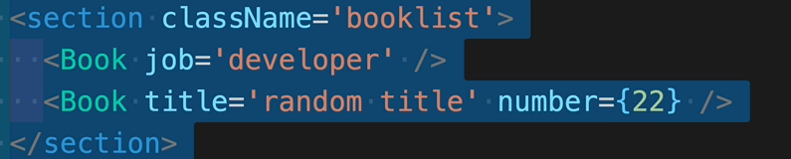

**The first call will render the variables, but only the prop “job”, since it is the only one that it has**



**The second one doesn’t have the prop job, but it has title and number so it will display those.**



**CALLING PROPS WHICH DON’T EXIST WILL NOT RETURN AN ERROR.**

**(026 – Props Destructuring)**

**Without writing the props word when definind our object, I can just say that our Book const will have an object as props by writing {} and the fields of this object.**

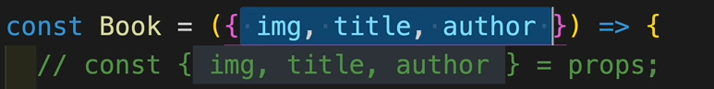

**And below I can just use the field name without having to write props.*fieldName\***

**What is commented in the picture above, is the second method of destructuring props. We can write**

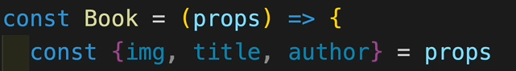

**Keep in mind that both the second method, and the first are doing the exact same thing and there is no difference in functionality.**

**(027 PROPS – CHILDREN)**

**Any prop object has a field called children by definition**

**When we create a book object, besides the props that we give in its definition we can also write other paragraphs or anything else within that object brackets**

**Those attributes will be stored in the props children variable.**

**So for instance we can see that the book object has three props called image,title and author and within his definition also has a paragraph. that paragraph is stored in the children of the props.**

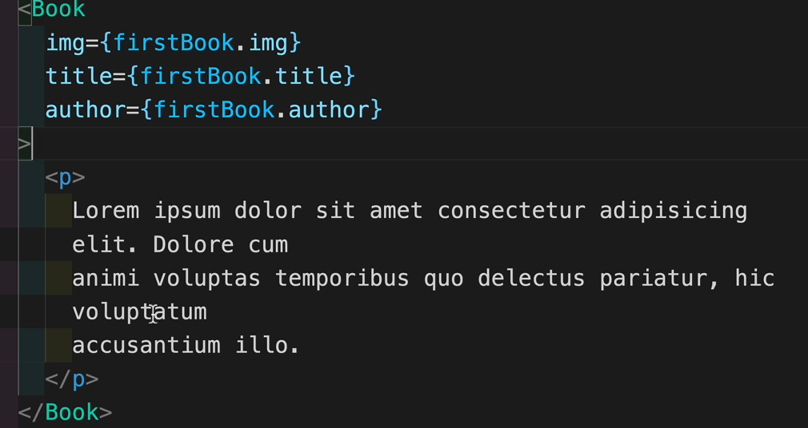

**And we can simply call it by calling props.children as shown in the next image**

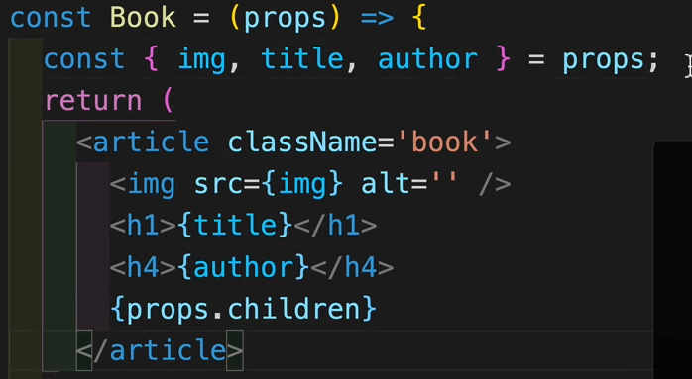

**(029 proper list) Props as objects**

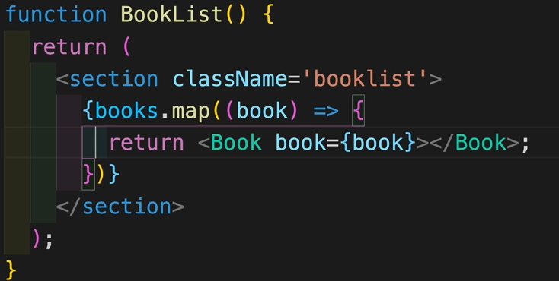

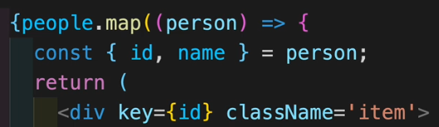

**Always remember when using the map function to map by the key id of the item.**

**When we pass the props to the book object, we can also pass it as an object.(called book in our case.)**

**We can destructure it, by simply calling props.book.**

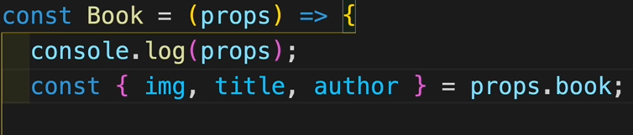

**(030 Key Prop and Spread Operator)**

**We saw that we can pass an object as a prop and get its parameters after.**

**What we can also do is pass the parameters of that object separately, by using the spread operator on that object like this.**

**So instead of calling our component like this**

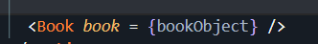

**And then getting its parameters like this**



**We can call our component like this**

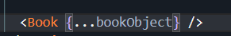

**And then the parameters are already spread, we only have to save them in some variables directly from props**

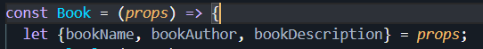

**Both methods are exactly the same and yield the same result.**

**(031 Event Basics)**

**For accessing all possible events:**

**Google “React events” and choose SyntheticEvent option.**

**If we need to use an event we have to have 2 things : an attribute and the event handler ( basically what event we capture and what happens when that event is captured)**

**We can set up an event easily like this:**

1. **With an inline function**



**For the attribute onClick, the event handler represents the logging of that book’s name.**

1. **With a reference**

**The event handler can also be a function that is declared in another place.**

**Our function/event handler:**

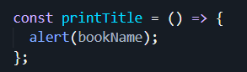

**And then just call the function**



**This method automatically calls the function, so it might be better to use the next method, calling the function after () =>**

**This 2nd method might also be the problem for the “Too many re-renders” error if we are calling a hook function with it.**

**If our function has parameters**

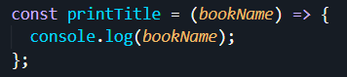

**Then when we call it we have to pass it as an arrow function**



**If we want to find details about our event, any event has the event parameter built into it so call a function**



**And do operations with that event**

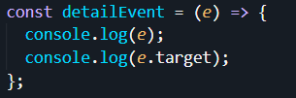

**(033 Free Hosting)**

**How to host your react app online for free**

**(038 – use State)**

**Conventions:**

1. **Is before the word for booleans : isLoading, isFound etc…**
2. **Set before the name of the function : [isLoading, setIsLoading], [isFound, setIsFound]**

**Let’s say we have a title displayed on the screen and we would have a button for which the event would be to change that title’s value.**

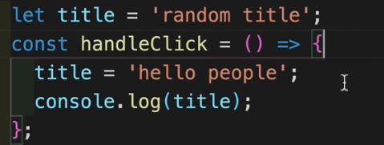

**Would the title displayed on the screen change when we click that button?**

**NO**

**That’s because we are not re-rendering the component when the button is clicked. On top of that, we would not have a way to keep that new value of the title in between renders as well.**

**So we will use the useState hook.**

**The useState hook will preserve the value between the renders, and trigger a re-render.**

**Notice that when importing it, we have to use a named import**



**Now what is useState? Use State is a FUNCTION.**

**It returns an array of 2 elements:**

1. **A variable (it can be a string, a value, a boolean, an object, anything)**
2. **A function (it is a function which controls that variable)**

**Now since the useState hook returns an array, we can destructure that array.**



**In our case, our variable will be called text and will have the value ‘random title’ and the function which works on that variable will be called setText.**

**When calling the useState for the first time as above, we can also pass in an empty string, an empty object, and empty array and so on.**

**The type of variable we pass in at the beginning does not mean that that object will be of that type forever. We can initialize our variable as a string and later use the setText function to change our variable to an object or to an array or etc, and it will work.**

**Now back to our example, if instead of assigning the variable with a new value we would use the setText function to do that, we will have the desired outcome**

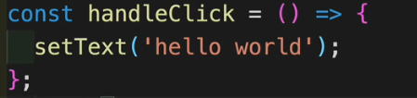

**(040 General Rules of Hooks)**

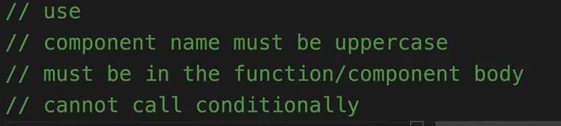

**(042 useState – Object Example)**

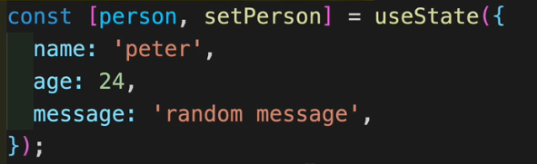

**If we initialize an object (called person) using the useState function, and then want to change one attribute’s value of that object, we might encounter problems.**

**As previously stated, the type we confer at the beginning is not immutable and if we were to call, for example, the setPerson like this**

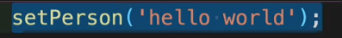

**The object’s attributes will be deleted and the object will become a string.**

**If we wanted, for example to change the message attribute and we would call like this**



**The message would be changed but the rest of the data would be wiped out.**

**The trick is to use the spread operator. That way, we keep the rest of the values unchanged.**



**We basically assign all the values back to the object, and then change only the attribute we want.**



**The hardcoded version also works, but don’t be the guy that does this 😊.**

**(045 – Functional Update Form)**

**Let’s assume we want to increment the value of a variable from a button, after a time, using the useState hook.**

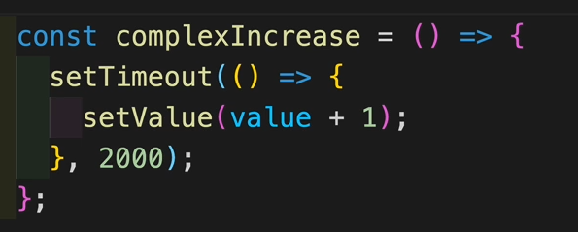

**The problem is, that no matter how many times we press the button, the value will only increment once because it holds track of the previous value.**

**The correct way to do that is to**

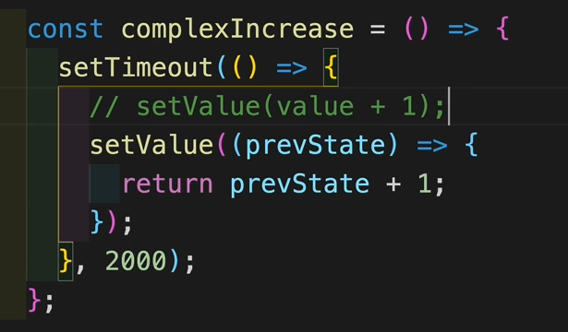

**Essentially creating a new variable that is updated for each press of the button and then assigning it to our original variable.**

**This is considered to be the functional approach.**

**Keep in mind that for this approach, we will have to have a return statement.**

**(047 – useEffect – Basics)**

**The useEffect hook tipically helps you deal with side effects / work that comes from outside of the component.**

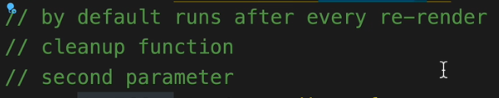

**For instance**

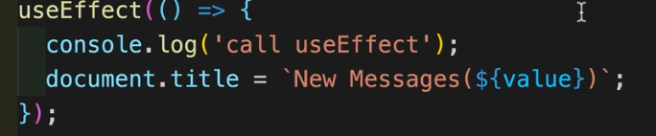

**The useEffect is simply called to modify the title of our document with the form “New Messages(0)” or 1 or 2 or whatever value we have, because that value will be kept between re-renders. We can click a button and update the value by using the useState hook.**

**The second parameter of the useEffect hook is a list of dependencies.**

**If we were to give an empty array as the second argument, the hook would only work for the initial render, not anymore after that.**

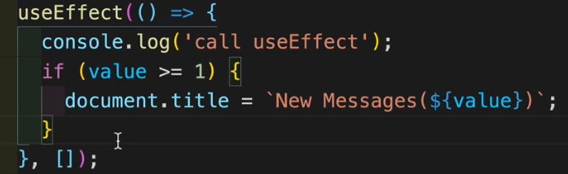

**The useEffect hook will look in the list of dependencies and only work when a variable from that list changes its value.**

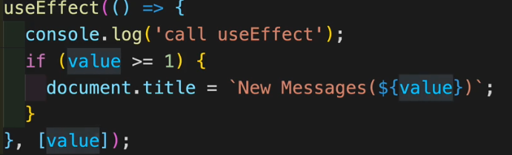

**Right here, we are back to our intitial functionality. The useEffect will be called for the initial render (obviously) and when the ‘value’ variable is updated.**

**We can have as many useEffects as we want.**

**(050 UseEffect – CleanupFunction)**

**Let’s take an example of using the useEffect hook to display the width of our screen for each re-render.**

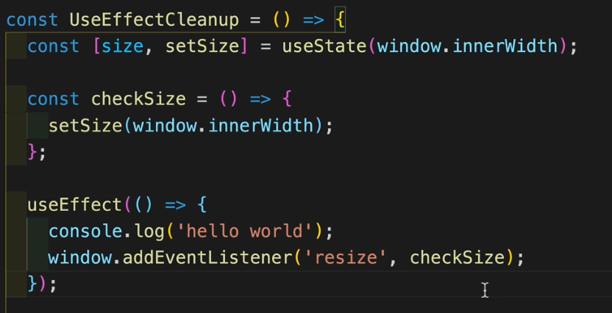

**This might impose some problems though, because we will have an event captured for each re-render, and that will cause problems with the eficiency.**

**The trick is to have something called a cleanup function, which will clean / remove the event listener of the previous event captured, but will still work for each re-render.**

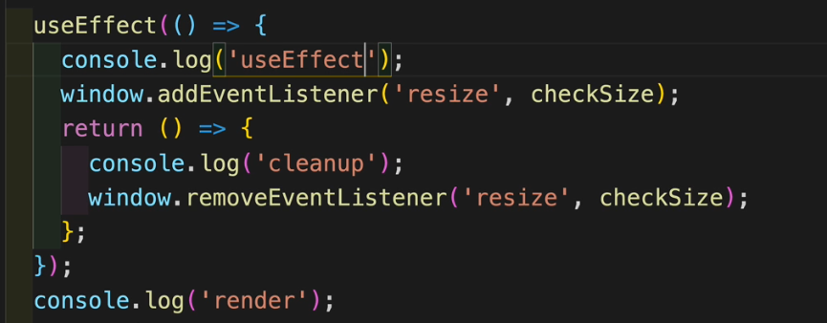

**So basically in this case, the useEffect is called for the initial render. After that, each time the window is resized, the useEffect will be called, a re-render will be triggered, but right after that re-render, before we add another eventListener, the previous eventListener will be removed.**

**The useEffect is called for each resize, because a resize triggers a re-render.**

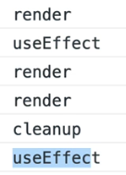

**The cleanup function will be very useful when we’ll deal with components appearing and dissapearing from the screen.**

**(051 useEffect – Fetch Data)**

**Fetching data without using libraries like axios**

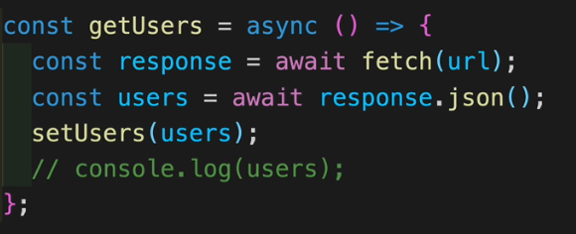

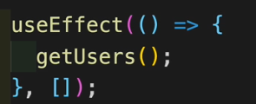

**Don’t try to use async fetch inside the useEffect because it will not work.**

**(053 Multiple Returns – Fetching Example)**

**This is how u can use sync fetch inside the useEffect**

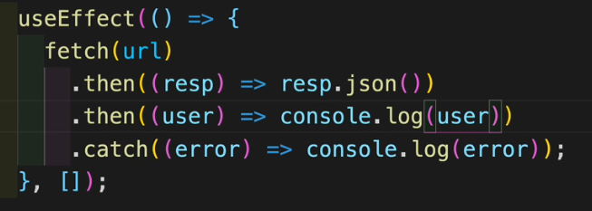

**(054 Short-Circuit Evaluation)**

**Short circuit evaluation is used by javascript.**

**When we have an OR statement, if the first operand of that OR is true, javascript will ,,short-circuit” the next operand, because there is no need to check it.**

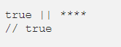

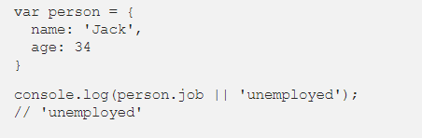

**For example, in this case, person.job is undefined, which is a false value. So that console.log will print unemployed to the console.**

**In react**

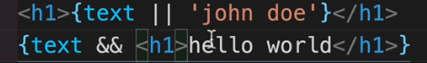

**For the OR Operator:**

1. **If value of text is truthy -> we return the text value**
2. **If value of text is falsey -> we return the string ‘john doe’**

**For the AND Operator:**

1. **If value of text is truthy -> we return the next element (in our case, a header1 with hello world)**
2. **If value of text is falsey -> nothing gets rendered**

**These operators, together with the ternary operators, can be very useful when choosing to display or to hide elements or even full components.**

**(058-060 Form Basics)**

**Useful Forms, check the files.**

import React, { useState } from 'react';

*// JS*

*// const input = document.getElementById('myText');*

*// const inputValue = input.value*

*// React*

*// value, onChange*

const ControlledInputs = () => {

  const [firstName, setFirstName] = useState('');

  const [email, setEmail] = useState('');

  const [people, setPeople] = useState([]);

  const handleSubmit = (*e*) => {

*e*.preventDefault();

    if (firstName && email) {

      const person = { id: new Date().getTime().toString(), firstName, email };

      console.log(person);

      setPeople((*people*) => {

        return [...*people*, person]; // whatever we have previously in the array, // save it and also add the newly created person. We concatenate the array.

      });

      setFirstName('');

      setEmail('');

    } else {

      console.log('empty values');

    }

  };

  return (

    <>

      <article>

        <form *className*='form' *onSubmit*={handleSubmit}>

          <div *className*='form-control'>

            <label *htmlFor*='firstName'>Name : </label>

            <input

*type*='text'

*id*='firstName'

*name*='firstName'

*value*={firstName}

*onChange*={(*e*) => setFirstName(*e*.target.value)}

            />

          </div>

          <div *className*='form-control'>

            <label *htmlFor*='email'>Email : </label>

            <input

*type*='email'

*id*='email'

*name*='email'

*value*={email} // here we link the value written in the input with //the state variable

*onChange*={(*e*) => setEmail(*e*.target.value)}

            />

          </div>

          <button *type*='submit'>add person</button>

        </form>

        {people.map((*person*, *index*) => {

          const { id, firstName, email } = *person*;

          return (

            <div *className*='item' *key*={id}>

              <h4>{firstName}</h4>

              <p>{email}</p>

            </div>

          );

        })}

      </article>

    </>

  );

};

export default ControlledInputs;

**(061 Multiple Inputs)**

**Same example as before but done dinamically so we don’t have a state variable for each input**

import React, { useState } from 'react';

*// JS*

*// const input = document.getElementById('myText');*

*// const inputValue = input.value*

*// React*

*// value, onChange*

const ControlledInputs = () => {

  const [person, setPerson] = useState({ firstName: '', email: '', age: '' });

  const [people, setPeople] = useState([]);

  const handleChange = (*e*) => {

    const name = *e*.target.name;

    const value = *e*.target.value;

    setPerson({ ...person, [name]: value });

  };

  const handleSubmit = (*e*) => {

*e*.preventDefault();

    if (person.firstName && person.email && person.age) {

      const newPerson = { ...person, id: new Date().getTime().toString() };

      setPeople([...people, newPerson]);

      setPerson({ firstName: '', email: '', age: '' });

    }

  };

  return (

    <>

      <article *className*='form'>

        <form>

          <div *className*='form-control'>

            <label *htmlFor*='firstName'>Name : </label>

            <input

*type*='text'

*id*='firstName'

*name*='firstName'

*value*={person.firstName}

*onChange*={handleChange}

            />

          </div>

          <div *className*='form-control'>

            <label *htmlFor*='email'>Email : </label>

            <input

*type*='email'

*id*='email'

*name*='email'

*value*={person.email}

*onChange*={handleChange}

            />

          </div>

          <div *className*='form-control'>

            <label *htmlFor*='age'>Age : </label>

            <input

*type*='number'

*id*='age'

*name*='age'

*value*={person.age}

*onChange*={handleChange}

            />

          </div>

          <button *type*='submit' *className*='btn' *onClick*={handleSubmit}>

            add person

          </button>

        </form>

      </article>

      <article>

        {people.map((*person*) => {

          const { id, firstName, email, age } = person;

          return (

            <div *key*={id} *className*='item'>

              <h4>{firstName}</h4>

              <p>{email}</p>

              <p>{age}</p>

            </div>

          );

        })}

      </article>

    </>

  );

};

export default ControlledInputs;

**Dynamic Object Keys**

**Notife that when we console.log the app object, its attribute now is called loading.**

**That is because if I create a varriable called appState and instantiate it to the value loading and then I create an object which has as an attribute, the appState between square brackets, the attribute will not have the name appState but the name of its value.**

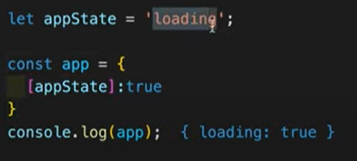

**Why is this useful?**

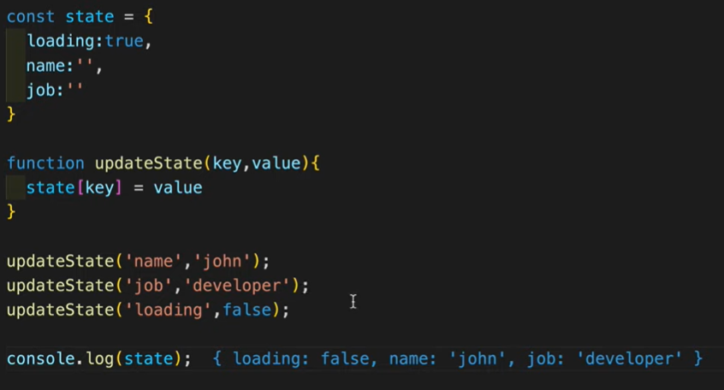

**Let’s say we have an object called state and we want to change the values of its attributes, dynamically.**

**My updateState function does exactly that.**

**Also, I can also call this function with a new attribute for our object, and the object will now have this new attribute.**



**(063 UseRef)**

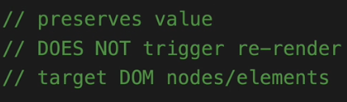

**For a form, we have what we call controlled inputs.**

**The useRef hook helps us to deal with uncontrolled inputs.**

**We start by creating 2 variables**

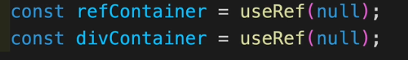

**The useRef hook, passes to our variables the initial vallue of null.**

**Now for any HTML element, we can write the ‘ref’ attribute and set it equal to a ref variable.**

**In this case, the ref is on an input element and on a div.**





**What we can do with this, is see which element has the reference, get its value etc.**

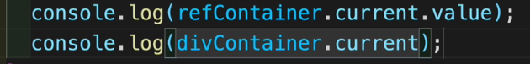

**And the outputs will be, as can be seen, the value of the referenced element and the referenced element itself.**

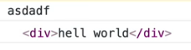

**Another cool thing we can do with the useRef hook is to focus a certain element. Like if we have a form, make a ref variable for the first input of the form, and make it gain focus.**

**And we will ofc do this by using an useEffect hook, since it calls itself after each re-render.**

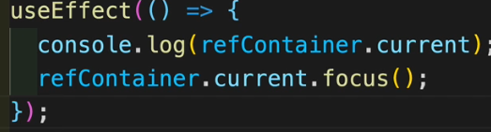

**(065 useReducer – useState Setup)**

**The useReducer hook, returns just like the useState hook, a value and a function. This function is called a DISPATCH FUNCTION.**

**To the useReducer, we pass the REDUCER FUNCTION and the default state ( the default state is the value with which our state will be initialized).**



**Each time u want to do something with that state, you must always use the dispatch function.**

**The default state is a variable that we create for our functionality.**

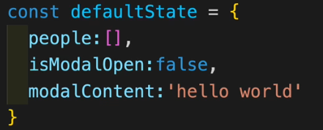

**For this example, we have a simple input with a button. When we submit the name, the name is saved into the people array and based on a boolean called isModalOpen, the modelContent will be displayer.**

**These attributes of my defaultState object were previously state variables. This is exactly what the useReducer helps us to do. Have less state variables and make our application more modular.**

**Now, let’s use the dispatch and the reducer functions.**

**THE DISPATCH FUNCTION DISPATCHES THE ACTION AND THE REDUCER FUNCTION, BASED ON THAT ACTION, RETURNS A STATE.**

**In our case, let’s say if a name was inserted into the input, we dispatch the TESTING action.**

**The form of a dispatch function is that it takes in an object (This is called the action) with the attribute called TYPE (The name of the action), which has a value written in UPPERCASE.**

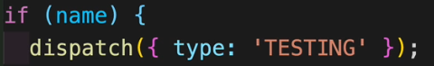

**In case we need to also dispatch some values to the reducer function.**

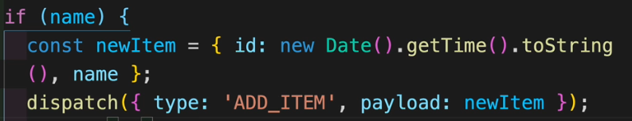

**We can do it by also adding an attribute which is tipically called PAYLOAD to the action we dispatch.**

**The form of the reducer function is that it takes the old state, takes the dispatched action and gives back the new state.**

**In the reducer function, we then declare the functionality for each type of action.**

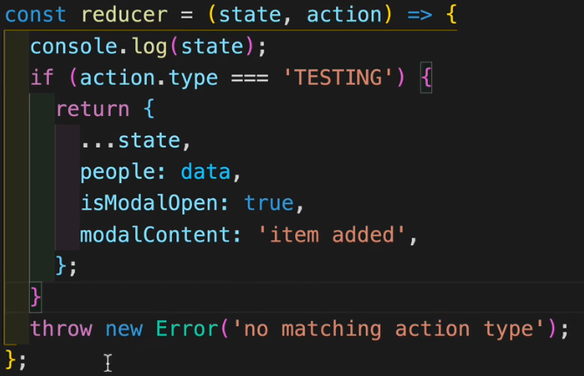

**As it can be seen, for the action of TESTING, we return the state with the spread operator ofc, so we copy the old values and then modify which values we want. We also tacke the option when we don’t receive an action that we know by throwing an error message ( We could also just return a basic state)**

**Also, reducer functions can get pretty big so we normally write them into a separate file !!!**

**(069 Prop Drilling)**

**This is not an official term.**

**Let’s assume we have a window component. Let’s assume on this window compoment we have rendered a list component. Let’s assume this list component has in itself more people component.**

**In our window component, we have a function to remove a person from the window. But we have to pass the prop of the id of the person and the method to delete that person ( a method can also be passed as a prop) to delete from the window to the list component, and then from the list to the person component.**

**This is prop drilling. Where we have to pass props down the chain of the command even if we do not want to.**

**The example is given below**

import React, { useState } from 'react';

import { data } from '../../../data';

*// more components*

*// fix - context api, redux (for more complex cases)*

const PropDrilling = () => {

  const [people, setPeople] = useState(data);

  const removePerson = (*id*) => {

    setPeople((*people*) => {

      return *people*.filter((*person*) => *person*.id !== *id*);

    });

  };

  return (

    <section>

      <h3>prop drilling</h3>

      <List *people*={people} *removePerson*={removePerson} />

    </section>

  );

};

const List = ({ *people*, *removePerson* }) => {

  return (

    <>

      {*people*.map((*person*) => {

        return (

          <SinglePerson

*key*={*person*.id}

            {...person}

*removePerson*={*removePerson*}

          />

        );

      })}

    </>

  );

};

const SinglePerson = (*props*) => {

  const { id, name, removePerson } = *props*

  return (

    <div *className*='item'>

      <h4>{name}</h4>

      <button *onClick*={() => removePerson(id)}>remove</button>

    </div>

  );

};

export default PropDrilling;

**(070 Context API _useContext)**

**The problem of props drilling will be easily solved using the useContext hook.**

**We start by creating a context variable**



**Once created, this PersonContext will have in itself 2 components called**

**Provider and Consumer accessed by PersonContext.Provider and PersonContext.Consumer.**

**The provider works as a distributor.**

**Now for the previous example, let’s go to our root component and wrap it in the PersonContext.Provider Component.**

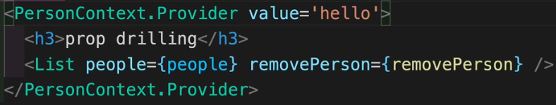

**The Provider has a prop called value, and this is what helps us get rid of prop drilling.**

**Now simply, in our 3rd component ( we had window -> list -> person)**

**just initialize a variable using the useContext with that Context u created before**

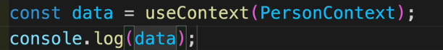

**If we log the value of data 🡺 ‘Hello’**

**As simple as that, we bypassed the 2nd component, not requiring to drill props down each level.**

**Now let’s refurbish our example. We send an object with 2 attributes ( removePerson and People) from our provider.**

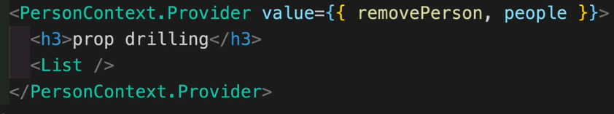

**And just destructure what we need in each component.**

**For the person component I just need the removePerson function**



**For the list component I just need the people array**



**And just do whatever we want with those.**

**Another useful tip is to create a const which represents our global context, and just that instead of calling the useContext hook and passing in our Context variable each time.**

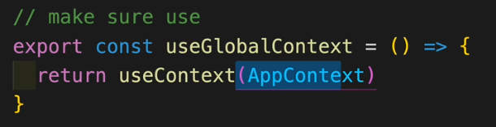

**And to use it, just call it in the component that u need.**



**(072 Custom Hooks – useFetch)**

**Custom hooks are basically components we export in which we return states.**

**So let’s say we have a functionality that we would want to use in multiple files.**

**Just copy that functionality in a new file that you create and return the state variables of your functionality.**

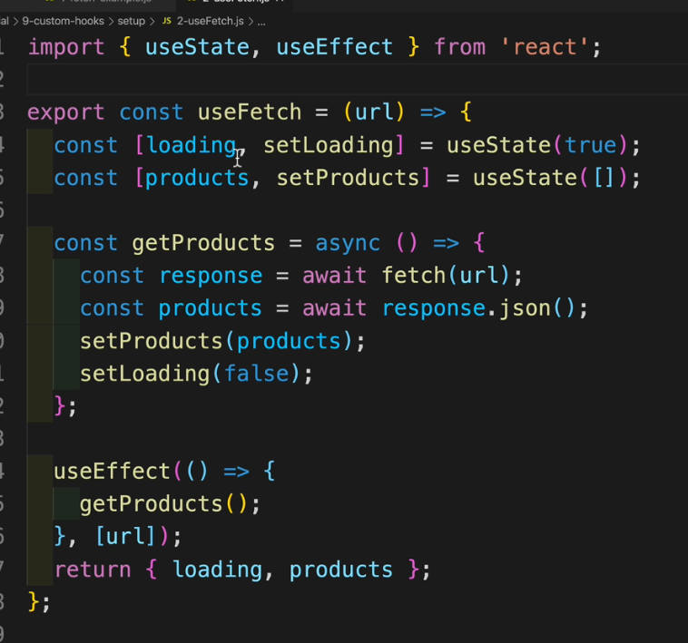

**And in another file, just call your hook.**



**Your custom hook has to start its name with the word use !!**

**(073 Prop Types – Setup)**

**Let’s say we have an API from which we fetch some data**

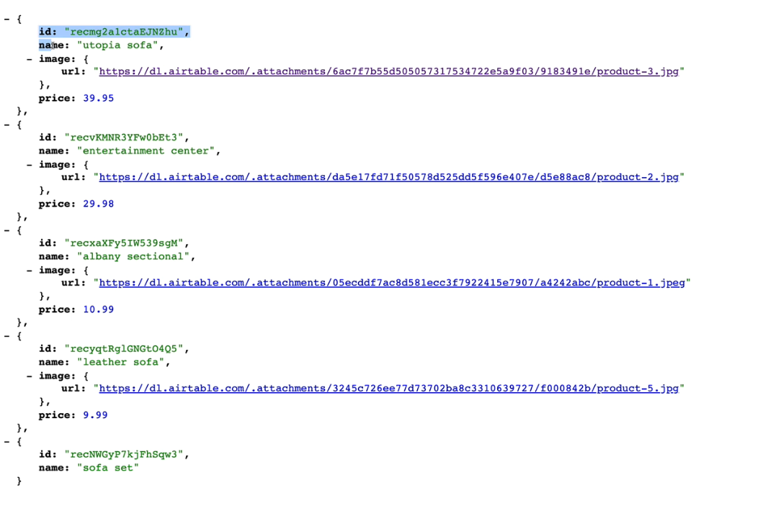

**As u can see, the last product is different because it doesn’t have an image nor a price as the rest of them do. If we were to pass the Product components with all those props, we will have some problems.**

**If we try to access the price prop for the last product, it will not work but it will not throw an error either.**

**If we were to try to access the url from the image prop ( which is an object) then we will get an error for accessing something undefined.**

**(074 PropTypes – Images)**

**To set up prop types, we simply import them**



**Now in our case, our Product Component had 3 props : image which was an object, name which is a string, price which is a number**

**So in our Product component, I’m gonna write those requirement**

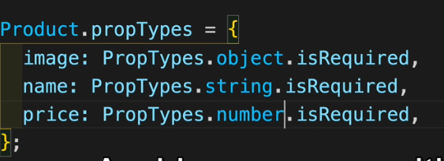

**HELPFUL SHORTCUTS:**

**If u want to write proptypes easily:**

**Write *nameOfProp*: ‘pt’ + *first letter of the prop’s type* + ‘r’ (from required)**

**Example : price: ptnr ( pt + n from number + r from required)**

**Setting up these propTypes will show in the console in case we are iterating through a list, if one of the elements is missing one of the props.**

**Now dealing with missing props can be done in 2 ways :**

1. **Setting up Default Props :**

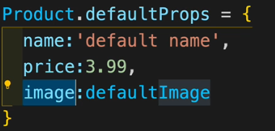

**For our component, in case any of those props is missing, just place the default prop in it.**

1. **Using Short-Circuit Operatos:**

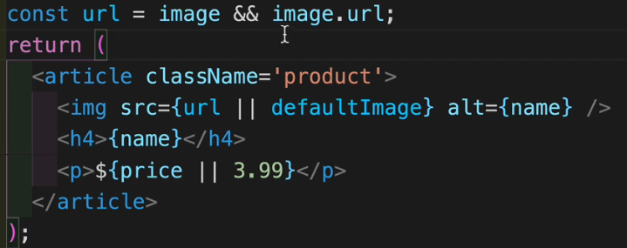

**For the url attribute of the img prop, check if the img exicts and return image.url in that case, otherwise return nothing.**

**For the price prop, return the price if it exists, otherwise just return a default value of 3.99$**

**(078 React.memo)**

**Let’s say we have a site with a button that increments a button and below we have rendered a List Component which is comprised of more Product components .**



**Because I use useState to increment the counter, each time I click the button, I trigger a re-render.**

**And this can be quite exhaustive because I re-render the list and each product every time, even though that is not needed**

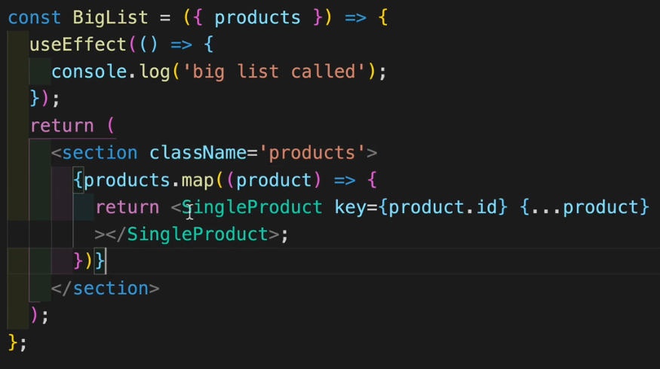

**This is how the list component looked like. The useEffect hook is used here just to show we trigger a re-render each time the button is clicked.**

**We can fix this (i.e not re-render each time) by using React.memo function**

**All we have to do is wrap our component in this function**

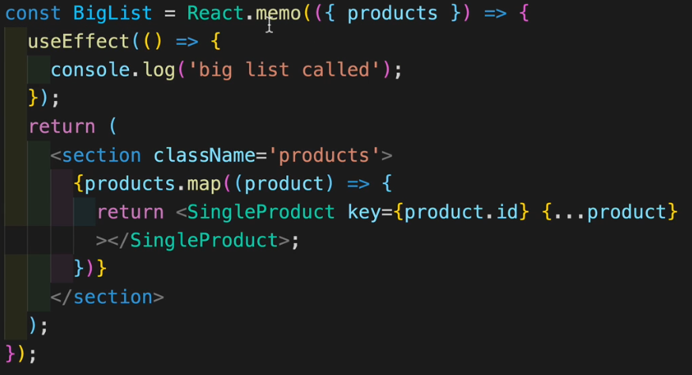

**And this solves our problem because the React.memo functions checks if its parameter ( in this case the parameter is { products}, the destructured list ) changed in any way, and if it didn’t then it doesn’t trigger a re-render.**

**Also, because of the way they are connected, since we do not re-render the big list, we don’t re-render each product either.**

**(079 useCallback)**

**The useCallback hook does the same thing as the React.memo function, but for a function instead for some props. If the value of a function which we pass down as a prop has not changed, then we do not trigger a re-render.**

**So for instance, for our previous example, let’s say we add a function into our big component to add an item to a cart (it will just increase a counter)**

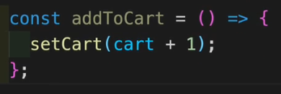

**We need to pass this function down to our list component and from it to the item component. We will do it this time using prop drilling.**

**Now we see that each time we click the button on the item Component which adds that item to the cart, we trigger a re-render of the big list and all the items (because this function is re-created from the scratch and react thinks ‘’ hey this is a new function, and because we pass this function down as a prop, that means the props changed so we need a re-render)**

**Now just like before, we took care of the re-rendering caused by the products prop by using React.memo. But this doesn’t solve the re-rendering cause by the addToCart function prop.**



**This will be used by using the useCallback hook.**

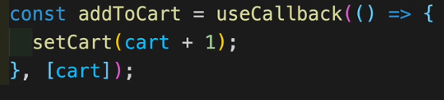

**useCallback also has 2 parameters:**

1. **The callBack function ( in this case, we just wrote it in-line style)**
2. **The dependency array**

**So we wrap our function into the useCallback hook and u can notice we also have a dependency array. We place the cart state value there so that this function is re-created only when the cart value changes. That will trigger a re-render**

**(081 useCallback -Fetch Example)**

**Another use for the useCallback hook**

**We can see in the terminal of our app the warning:**



**If we go back to our custom hook, useFetch:**



**We can see that we cannot solve this warning without creating an infinite loop. If we did place the getProducts into the dependency list, we can see the getProducts calls the setProducts state function, which triggers a re-render. And this will call our useEffect, and that will trigger the getProducts again and so on.**

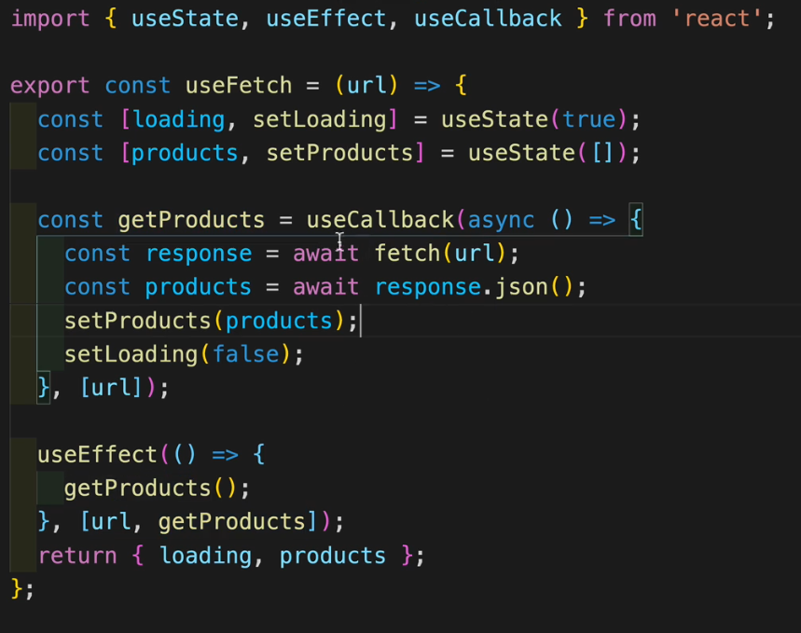

**So we can wrap our getProducts into the useCallback hook, and in the list of dependencies of the hook we place the url. So this getProducts function will be recreated only when the url changes, not for each re-render. And now we can also place the getProducts in the dependency list of the useEffect hook cause it doesn’t create an infinite loop anymore**

**(080 useMemo)**

**Main difference between React.memo function and useMemo hook is that React.memo is checking for the props and useMemo is checking for a specific value.**

**Let’s say for our previous example we create a function that does some calculations and sees which is the most expensive item in our whole list. (learn about the reduce function)**

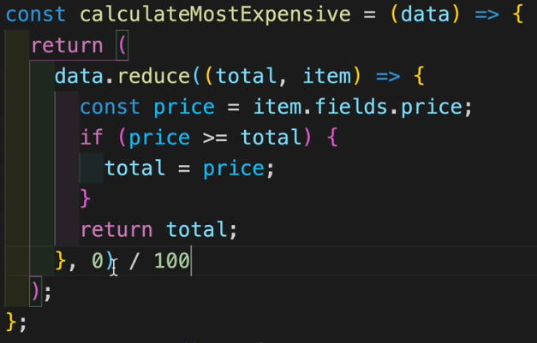

**This function might be exhaustive, and we might not need to calculate this most expensive value everytime, we would need it only when our products list changes.**

**So we use the useMemo hook:**

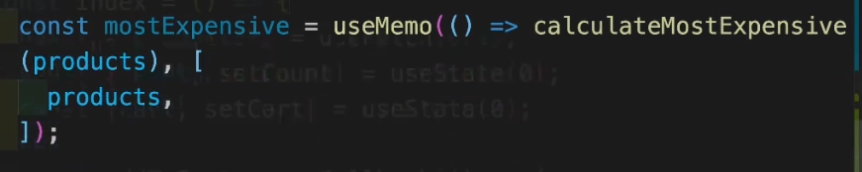

**We create a variable which receives useMemo. And the useMemo function receives 2 parameters:**

1. **A call backfunction ( basically which function to be re-called)**
2. **The dependency array ( when to re-call the call back function.**

**Now, wherever we need to display this most expensive price, we would show the mostExpensive variable, not the calculateMostExpensive function.** 

**(FOLDER 06 - React Router 6)**

**Command for installing library:**

**npm install react-router-dom@6**

**(165 Page Components)**

**Imports:**



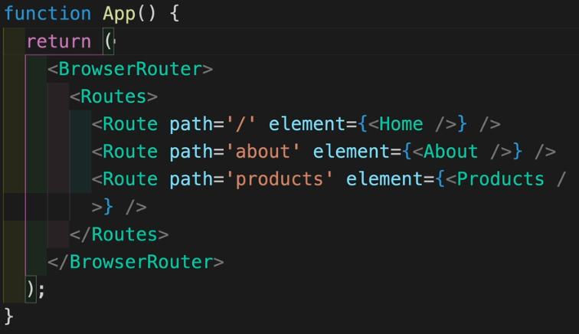

**The BrowserRouter will be the main element where we set the routes.**

**The Routes element will be the parent of all the Route elements.**

**The Route element is the element to which we pass the path attribute ( meaning the form of the url) and the element attribute to which we pass the Component.**

**In our example:**

**Home Component is at localhost:3000**

**About Component is at localhost:3000/about**

**(166 Link Component)**



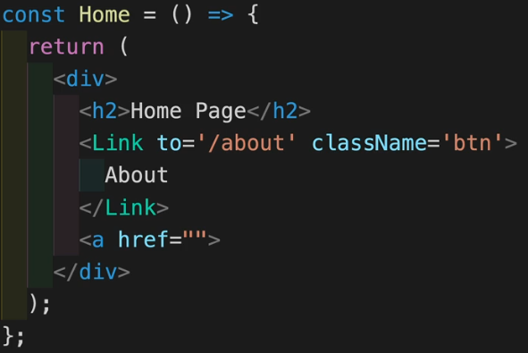

**If we wanted to create a link, like a button, from a component to another component, we use the Link element. For going to another website, to something outside our application, we will still use the classic a href.**

**(167 Error Page)**

**If by mistake we go to a route which doesn’t exist, we can create something default to be shown.**



**So, going to any route that we didn’t specify already, will make our app go to the Error Component in this case.**

**(168 Nested Routes)**

**Nested routes are routes that are relative to another route**

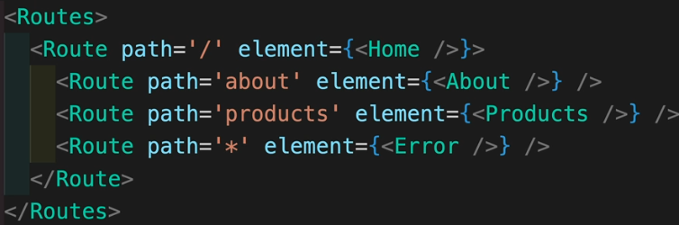

**In this example, to go to the Home Component, we go to localhost:3000/dashboard**

**To go to the About Component, we go to**

**localhost:3000/dashboard/about**

**Because the about page is relative to the home page and thus we have to pass through its route**

**(169 Navbar and Footer)**

**This is the simplest way to place a navbar and a footer**

**All we have to do is place them above and below, respectivelly, our Routes Component**

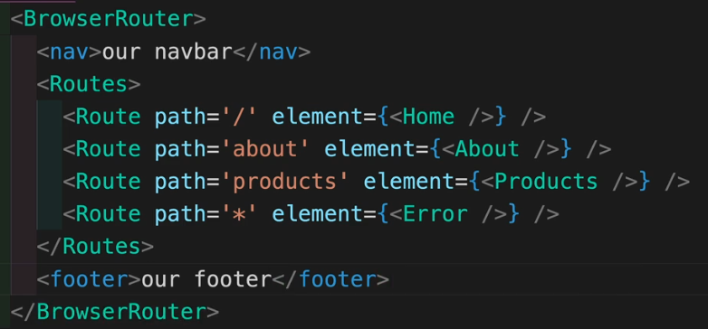

**(170 Shared Layout)**

**Now why are nested routes useful?**

**Because they allow us to use shared layout.**

**So we can create a navbar component**

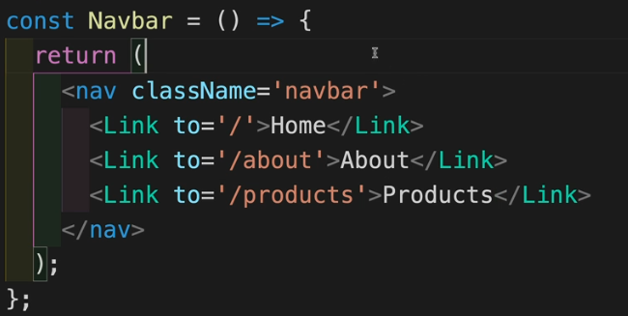

**And now, because we have the About Component and the Products Component nested in the Home Component, we go to the Home Component, call the Navbar Component in there and we use**

**the Outlet Element which basically says “whatever we have displayed in this home(the root of our nest) component, display also in all the nested components. ”**



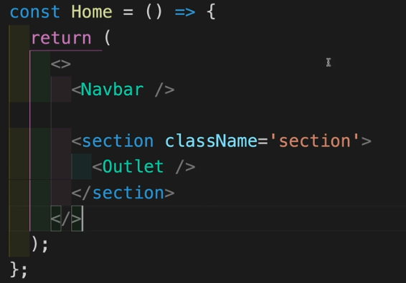

**(171 Index Pages)**

**The problem with the previous implementation is that the home page is empty. And if we were to put anything on the home page, it would show up on any of the other components nested in the home page. So how do we fix this?**

**We will use something call an Index Page.**

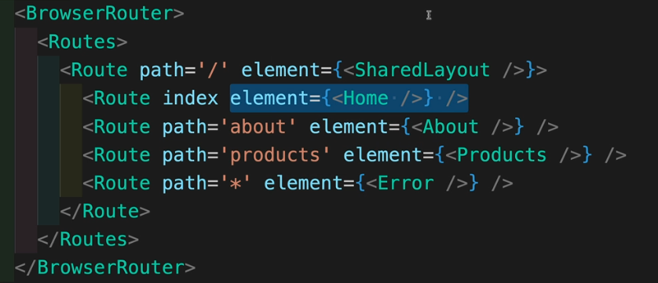

**The SharedLayout Component will have the base address of home but will be created only to house the Outlet Element.**

**The Index is declared as can be seen above which basically means that it has the same address as the root ( so the base address) but will show the Home element which we can now design as we wish.**

**So now the Home has whatever we want**

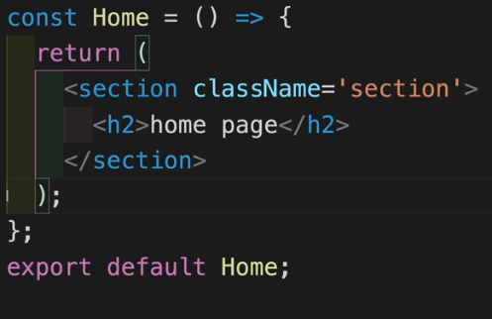

**And the SharedLayout Component has the sole purpose of calling the Outlet Element.**

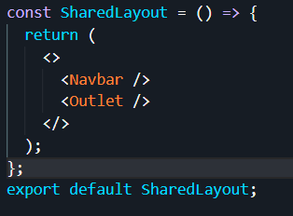

**(172 NavLink)**

**The NavLink is just an Element that has the same functionality as a Link element but can also be stylized more.**

**So for the NavBar, we simply replace the Link with NavLink. This, by default will add a color to the selected navlink, as opposed to the other.**

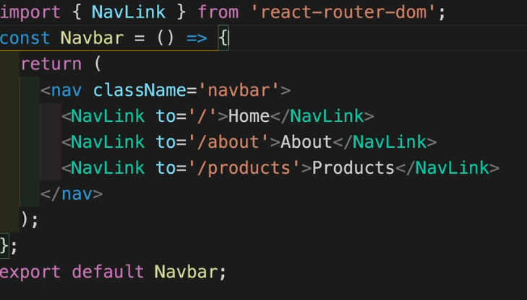

**But we can change this color by either, coding the css right into the navlink**

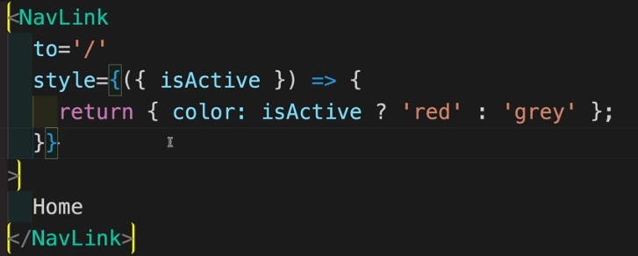

**OR, by modifying which classname the navLink should have, where the classNames are defined by us in the .css file**

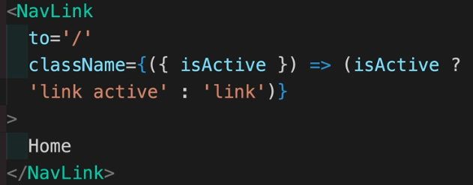

**Notice the isActive function. This is a pre-built function which holds true when that navLink is selected. So we are looking for a function and in that function, we are looking for an object and then we go with isActive.**

**(173 URL Params)**

**Think of a general products page, where u have many products and if u click on a certain product, you go directly to that product’s page. But we do not want to hardcode a page for each product, we will make one default page for a product which dinamically changes**

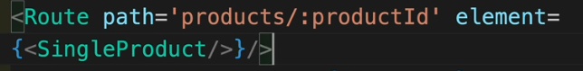

**So we will have a route for each product, based on its id.**

**In the SingleProduct component, we will use the**

**useParams hook.**

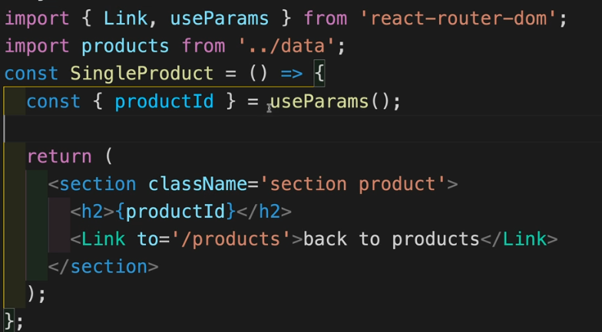

**The most important part is that the variable returned by useParams has to match exactly to the URL parameter we gave.**

** ⬄** 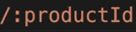

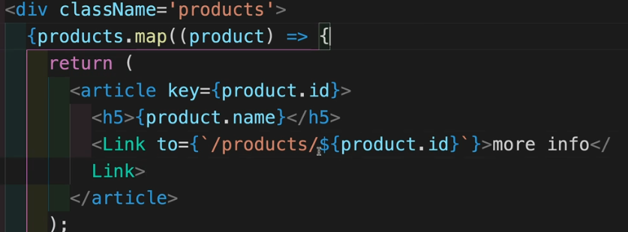

**In the Products Component, we can easily iterate through our list of items.**

**(175 useNavigate )**

**Let’s imagine a login interface. We log in, and we want to set up a user object, which holds our name and email.**

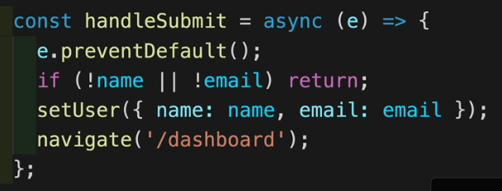

**This will be our onSubmit function. Once we have both, we will set a state variable and navigate to our home page. For direct navigation, we use**

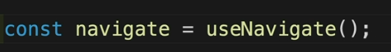 **Which is the useNavigate hook**



**This user object can be set up as a state value in the App.js**



**And from here we can easily pass what we want to the other components.**

**We will pass the user Object as a prop to the Home component because we want to display “hello, *userName*” on the Home**

**And We pass the setUser function to the Login Component because after the login, that’s where we set the user.**

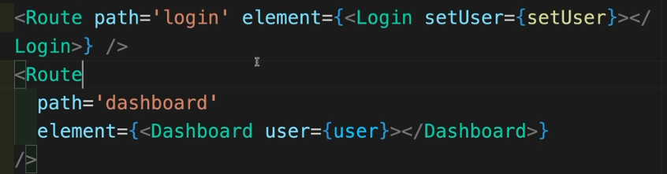

**On this example, we send the user as a prop to a Dashboard Component, which is essentially like a pop-up on the home page. And notice we use optional chaining. That means that if the user is undefined, it will not throw an error while trying to access the name attribute of something that is undefined.**

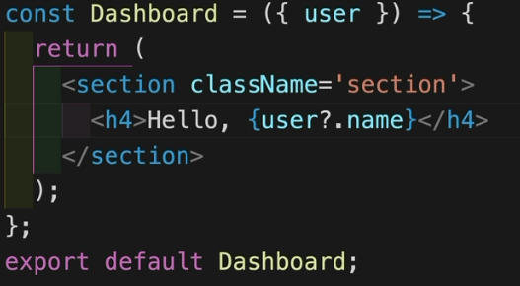

**(176 Protected Route)**

**How can we restrict access to a certain page?**

**Well we can set up a component called ProtectedRoute and whatever page we want to protect, we will wrap it in this ProtectedRoute component.**

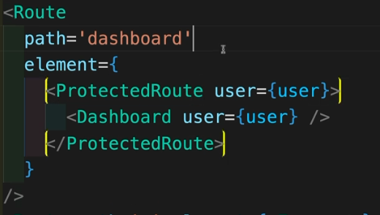

**So in our App.js, we went and wrapped the Dashboard Component in the ProtectedRoute Component. Remember that that means that the Dashboard Component is now a children prop of the ProtectedRoute.**

**So now in out ProtectedRoute Component we set up the logic:**

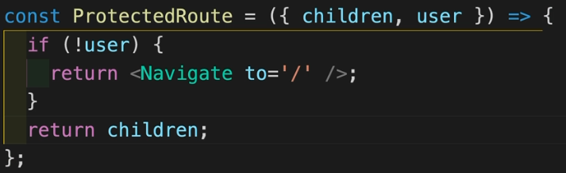

**We can simply say, if the user doesn’t exist, go back to the home page.**

**If the user does exist, then return the children prop, which is that dasboard with “hello *userName*”**

**(FOLDER 07 Axios HTTP Library)**

**Command for installation:**

**npm install axios**

**The way I previously used axios:**



1. **Get Mapping**



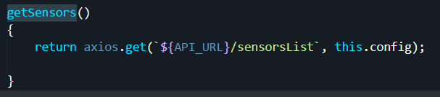

1. **Post Mapping**



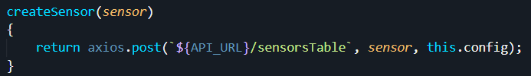

1. **Put Mapping**



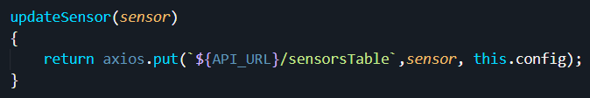

1. **Delete Mapping**



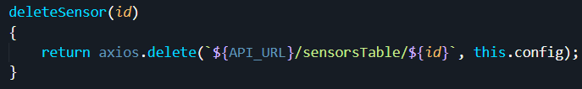

**(180 GET Request)**

**Axios.*requestName*(url) will invoke that type of request**

**Using just axios(url) will call the default GET request**

**These requests will return promises with the response being located in the data object and the error being located in the error.response**

**Another method of using axios, with async.**

**Axios makes things easier also because of the way it treats error. It captures every time of error ( also 404’s and others) not just network errors like fetch does.**

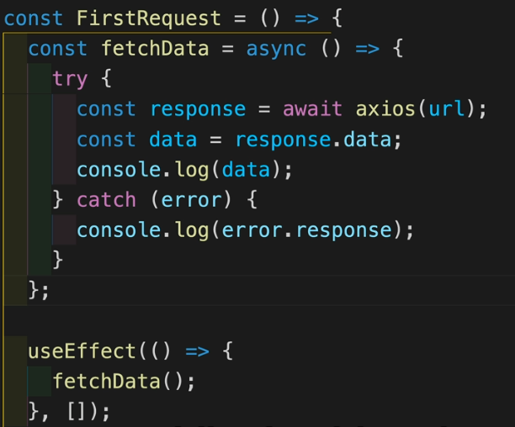

**HTTP Headers are ways to pass more information with an HTTP request from both the client and the server.**

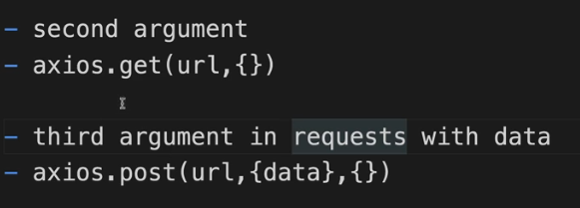

**This is an example:**

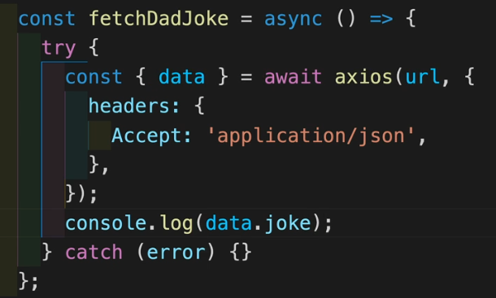

**This can also be seen in the way I passed the JWT token in the first examples of axios. This is how the header was constructed with the token.**

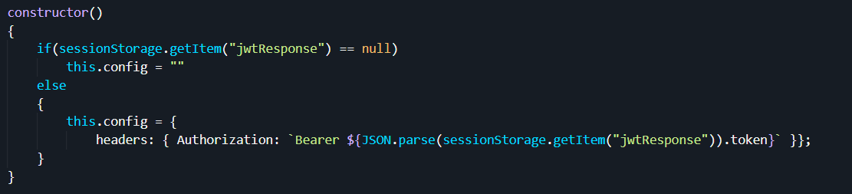

**(183 Global Default)**

**Global Defaults enable us to add functionality by default, to each http request. Meaning that everytime we use axios, this functionality will be called.**

**It might have been useful to know that for my jwt token.**

**First, let’s create a file called global.js and there we will place what we want. Some common examples:** 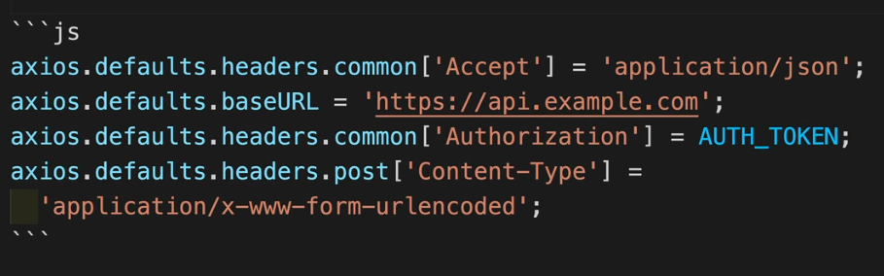

**Our Example:**

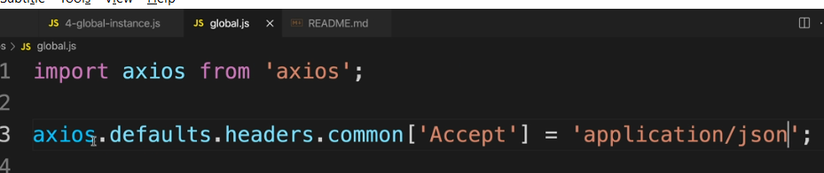

**Now we have to import this file into our root Component, so our App.js**

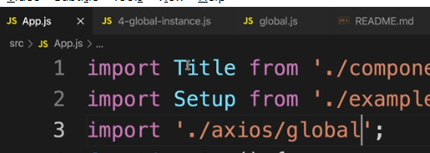

**And now, in the file where we want to use the axios request, we import axios normally and the global settings will be enforced.**

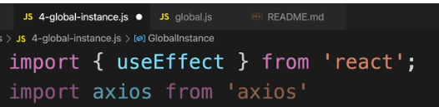

**(184 Custom Instance)**

**The previous approach has some problems, since in the case we deal with more servers, we might not want the same settings for all.**

**So we can create some custom instances as well.**

**So we create a new file called custom.js** 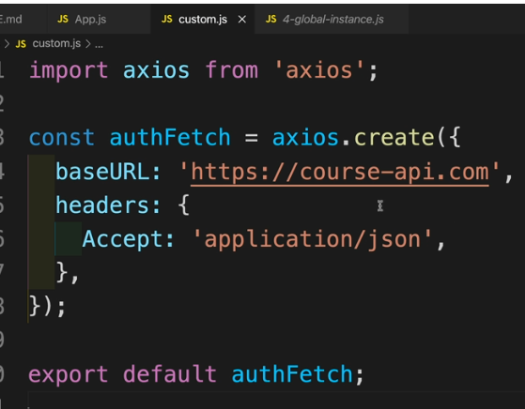

**And here is the main difference. In the file where we use the http request, we import both the custom.js file and the axios normally**

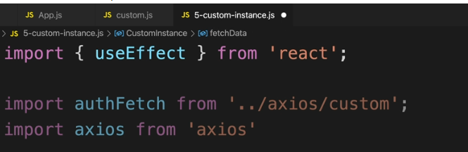

**When we use it, our baseURL will already be in place and we only have to call the rest.**



**In this case, the first request is our custom one and the second request is a normal one which still works by the global default**

**( 185 Interceptors)**

**Interceptors are functions that axios calls for every request and we can use them to transform the request, and add some logic.**

**RULES:**

1. **The form:**

**\*request*.interceptors.*either request or response*.use**

**2) After that, we pass in 2 functions as parameters:**

**- In the case of request for 3rd dot parameter:**

**- the 1st function accesses the request and we must return a request**

**- the 2nd function accesses the error**

**- In the case of response for 3rd dot parameter:**

**- the 1st function accesses the response and we must return a response**

**- the 2nd function accesses the error**

**So in this case we went with our previous custom instance for the request and a request for the 3rd parameter.**

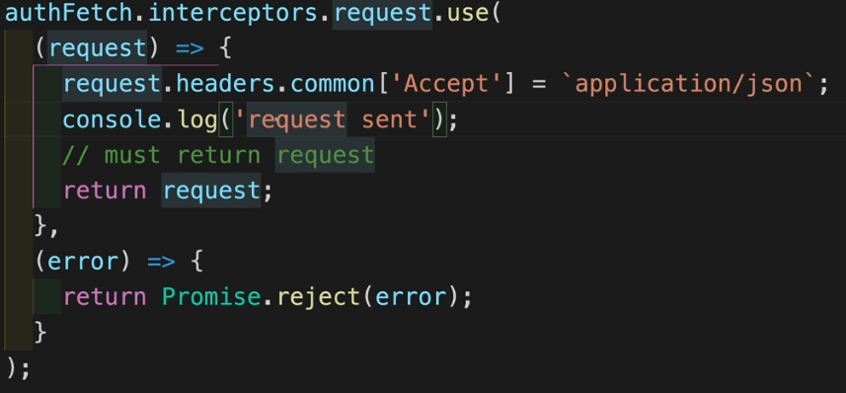

**In this example, we showcase interceptor for the response as 3rd dot argument**

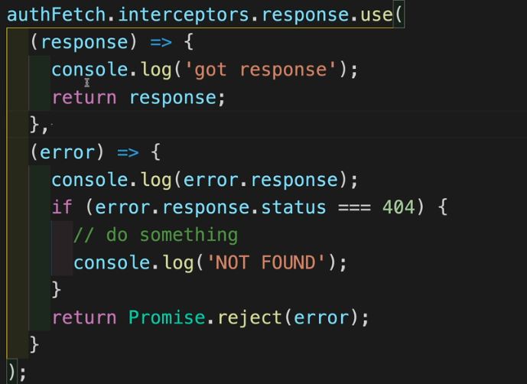

**We can use normal https request form like:**

**Axios.put.interceptors.response/request.use( …. )**

**To use this, we create a file called interceptors.js where we redefine our custom instance, and the interceptors shown above**

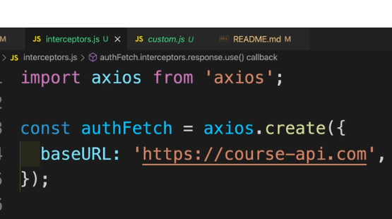

**And then, in the file where we want to use them, we import this authFetch and the functionality will be there.**

**Interceptors are also really useful when we deal with authentication.**

**We can look for instance at a console.log(error.response)**

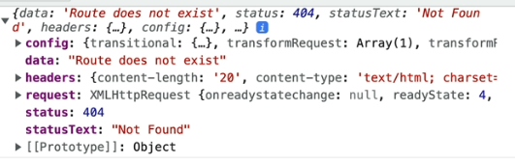

**And put conditions based on our errors. ( this is for the response interceptor)**

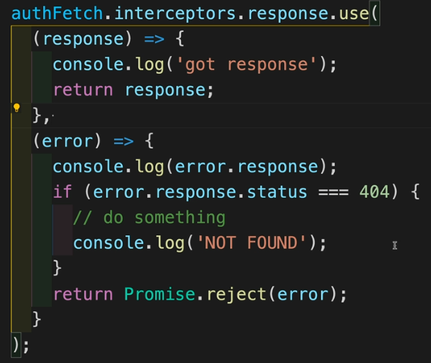

**SIDENOTE:**

**Moment.js library is very useful for working with dates.**

**https://momentjs.com/**

**(FOLDER 13 Redux Toolkit)**

**Link : https://redux-toolkit.js.org/**

**How to install:**

**npm install @reduxjs/toolkit react-redux ( this command is also for installing react-redux). The reason we also install react-redux is to connect react to redux.**

npm install @reduxjs/toolkit

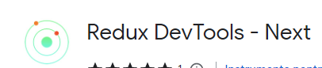 **This is the chrome extension**

**When we install, we actually install more libraries:**

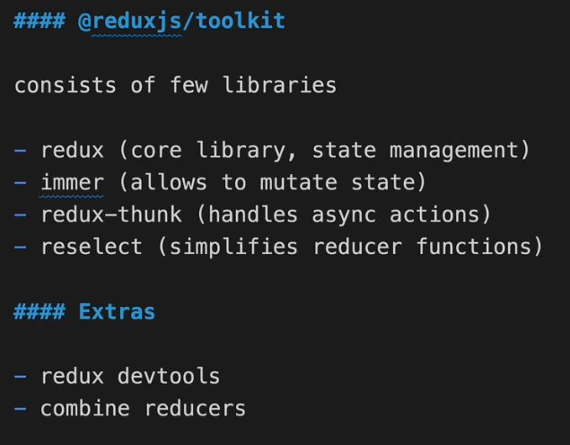

**(404 Store)**

**You can think of the store.js as the entire state of your application.**

**We start by creating a file called store.js with the needed imports. In this file, we are gonna export a variable called store.**

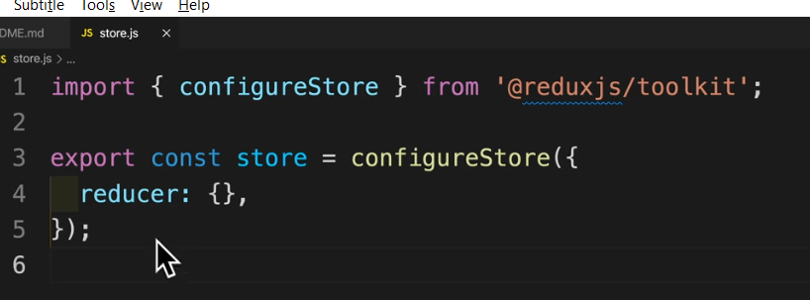

**For now, I just left the reducer part empty.**

**And now we go to the index.js, import the store variable and the Provider from redux, and we wrap our entire application with that Provider, while passing our store as a prop.**

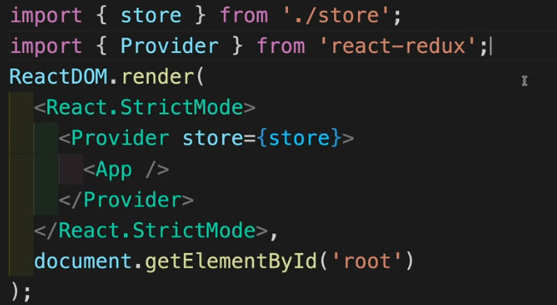

**(405 First Slice)**

**With the previous setup, we should see the following error in the console.**

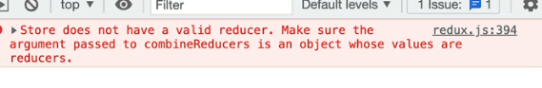

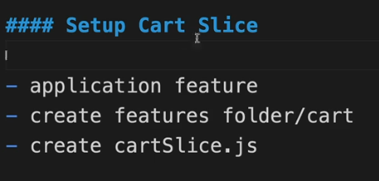

**A slice is the feature of our application.**

**The conventions are:**

1. **We create a folder named features**
2. **Inside this folder, we create a new folder with the name *featureName*. In our example, the folder will be named cart**
3. **Inside this cart folder, we create a new file called *featureName*Slice.js. In our example, this file will be named cartSlice.js**

**Ok, so in or cartSlice.js we’ll start by importing the createSlice function.**



**We create a variable called cartSlice which receives this function. As parameter to the function, we will pass an object and in this object we will set up a bunch of properties ( Our properties will be name and initialState but since initialState has a bunch of properties aswell, we will set it up as a separate object.**

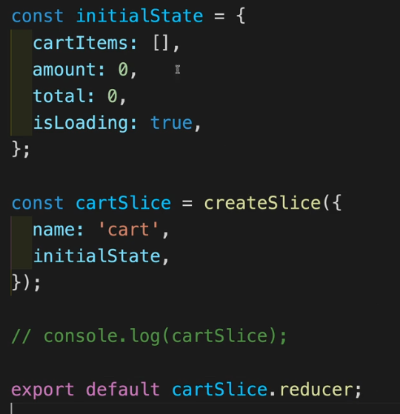

**Now let’s go back to the store.js and import this file.**

**As soon as we look into the console(for this console.log(cartSlice), we can already see multiple things.**

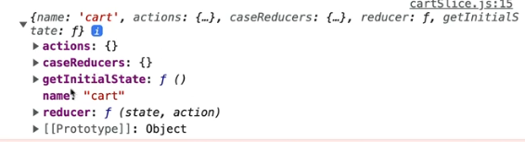

**All the way at the bottom, we see the reducer.**

**This reducer is the one that is going to control that state, in this slice.**

**So from our cartslice.js we export this reducer.**

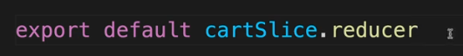

**Now in the store, we import it, and have to come up with a key and set it equal to this reducer (the key will be named cart in our case).**

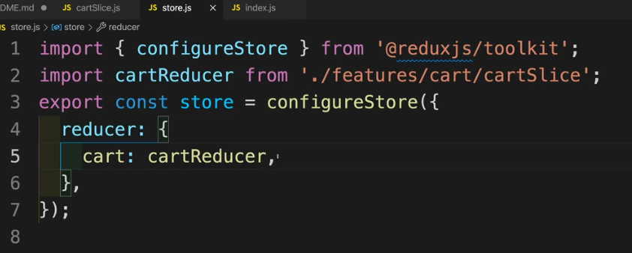

**(407 useSelector)**

**Now let’s see how we can access that initial state in any of the components.**

**The useSelector is a hook from react-redux.**

**Let’s say we create a navbar component for our app, and there we want to use this hook to get the total amount from our cart.**

**We can do that easily because we can access the entire state using the useSelector hook.**

**Our state, which we called initial state, has all the necessary information**



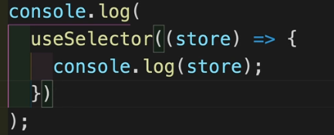

**We can see that we don’t need to import any function or any parameter.**

**We can just useSelector of our store (I would describe a store as the collection of all states)**

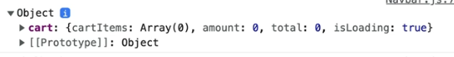

**And we can easily access any of those properties using this hook.**

**So we can simply get the total amount from the cart into a value like this**



**Or by using destructuring**



**(409 Cart Items)**

**This is how our data is structured.**

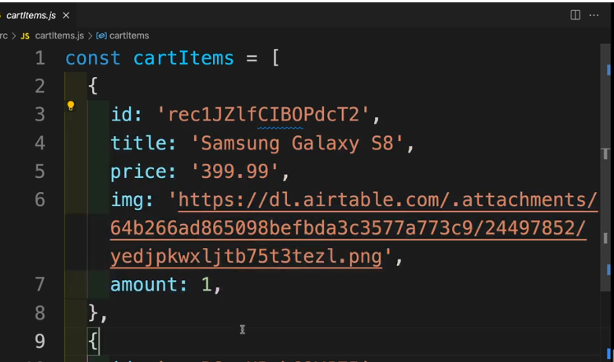

**In the store.js, we can import this cartItems list, and set it equal to the list of items in our initial state.**

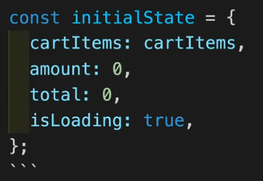

**(081 – Reducers – Clear Cart)**

**Now we can set up some reducers.**

**We can navigate to our cartSlice.js which right now looks like this**



**And create a reducer for our cartSlice**

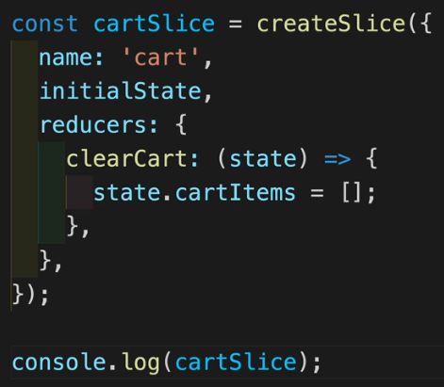

**And now we can see that our cartSlice has a new action, called clearCart**

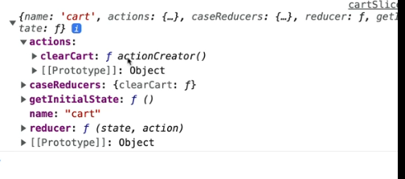

**Now we can simply export this action**

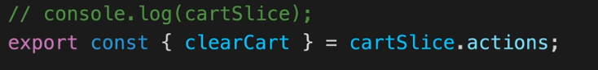

**Now go to whichever file we need it and to use it, we need to import it ( our action) and also a hook called the useDispatch hook**

**Create a new variable which receives this hook. Notice we do not have to pass anything to it.**



**And now we can simply use the dispatch function to dispatch our action. In our case, we click a button to delete all the items from our cart.**

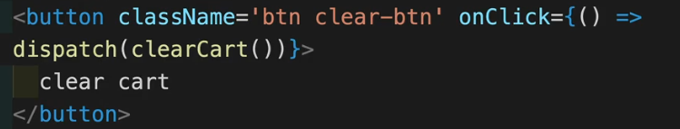

**(413 Reducers – Return State)**

**There is another way to creating a reducer for our slice, and that is to return a whole state.**

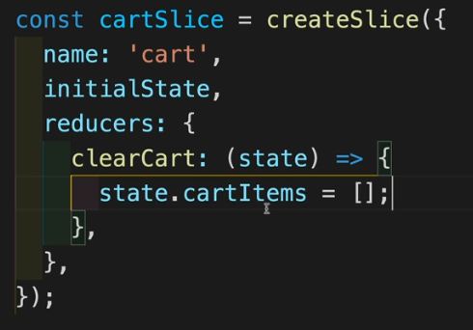

**BUT WE HAVE TO BE CAREFUL, BECAUSE BY THIS METHOD WE DELETE ALL THE OTHER PROPERTIES.**

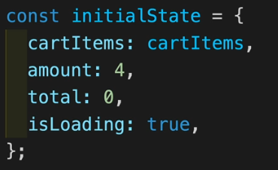

**Here are all the properties just so we remember. By using this method, we will delete all the others and just remain with the cartItems property.**

**But if we don’t ommit any of them, it will work very well and it might even come in handy.**

**(414 Reducers – Remove Item)**

**Let’s set up more reducers for our cartSlice.**

**Now for every reducer, we have 2 arguments:**

1. **The state, which has all the variables of that state which we can modify as we please. And as we saw in the previous example.**
2. **The payload. The payload contains whatever we pass as an argument to our action when we dispatch it.**

**Let’s set up a reducer that will delete one item from the cart based on its id.**

**Again, the state parameter is the one from which we access all the properties, and the action is the one from which we access the payload ( what parameters are passed to the action when invoked)**

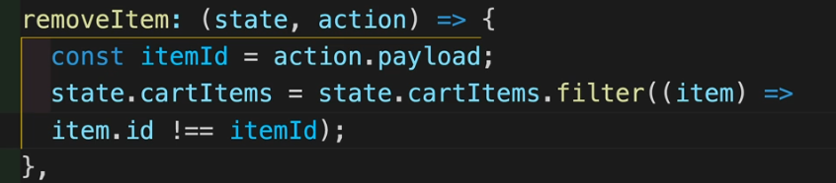

**Don’t forget to export the reducers.**

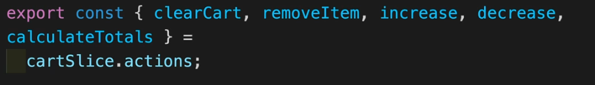

**Again, to use the reducer’s action, we import it together with the useDispatch hook.**



**We instantiate a dispatch variable with the useDispatch hook**

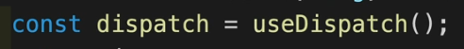

**And now we call the action of removing an item based on its id, while passing the id of the item in question.**

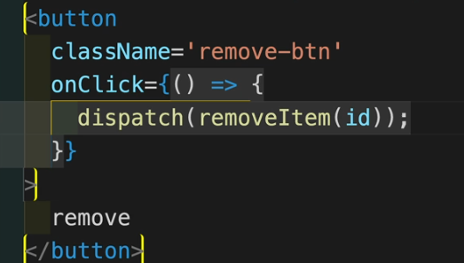

**This id will be stored in the action.payload from the reducer**

**Now, just to show that it’s possible, when we create a reducer, we can pass in the payload directly as a parameter, by destructuring what would have been the action parameter**

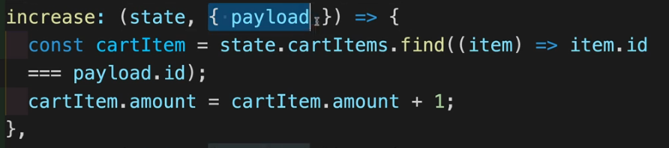

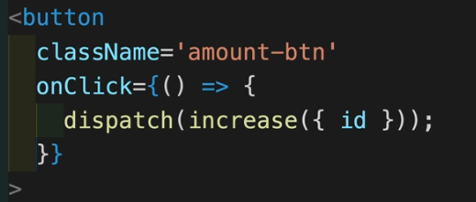

**This example is for increasing the amount of a certain item that we have in our cart.**

**The amount variable might be confusing. It doesn’t represent the sum of all amounts of each item from the cart but the amount of a certain item from the cart.**

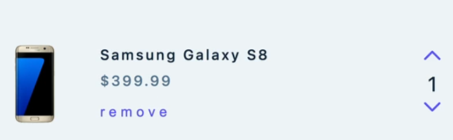 **⬄ cartItem.amount**

** ⬄ cart.amount**

**(418 Modal Complete)**

**A modal is a funky way of saying pop-up.**

**Let’s create a new slice for a modal, create and export reducers for it.**

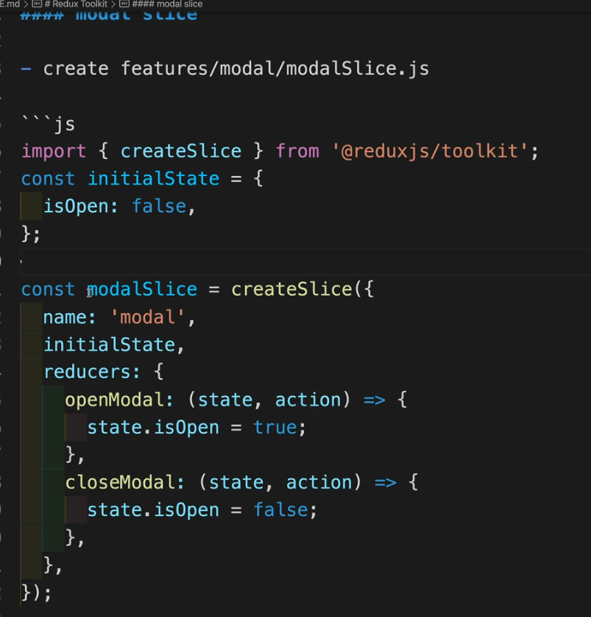 

**Now we go to the store and add our new reducer to the store**

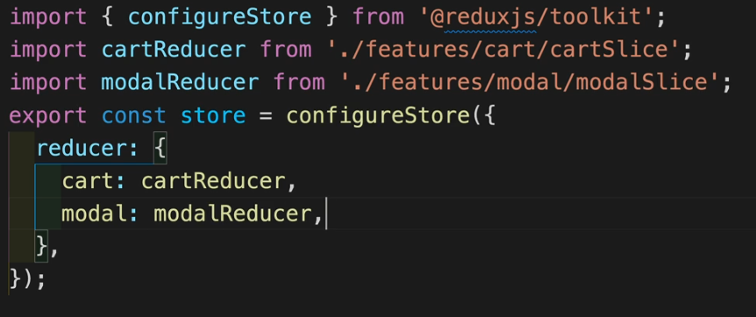

**And now we can use it. Create a modal component and use the needed dispatcher and actions where neccessarry**

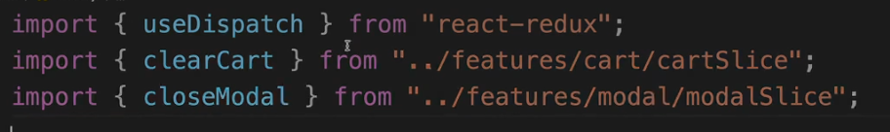

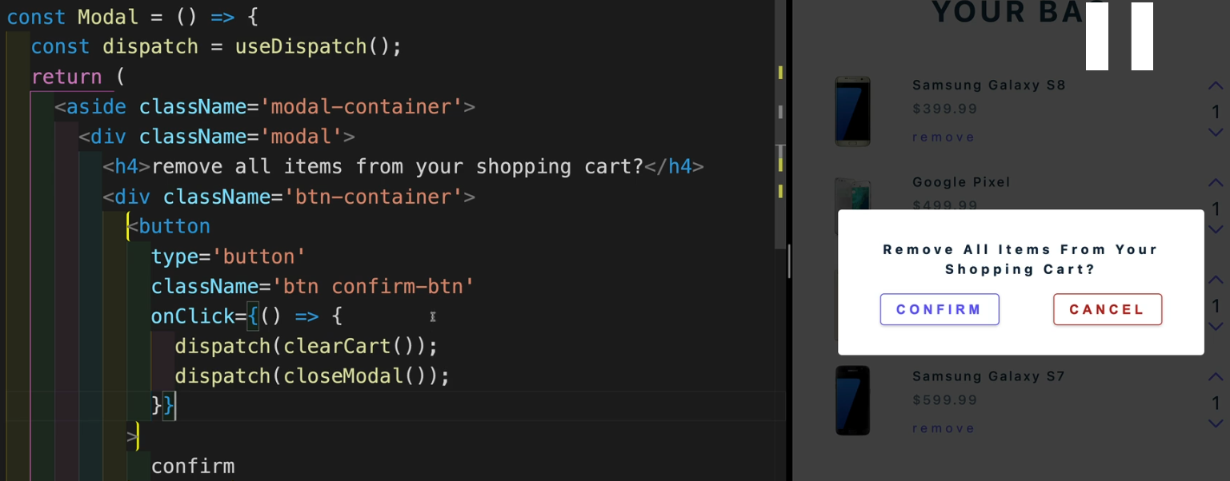



**(419 createAsyncThunk)**

**Now, to import data from an API, we’ll have to do some work.**

**Import createAsyncThunk from redux toolkit**



**Now we create a variable which will take this createAsyncThunk. CreateAsyncThunk takes 2 parameters:**

1. **The type. Here we just need to come up with a name (it will be our action’s name.**
2. **A callback function. This will be where we fetch the data from the url.**

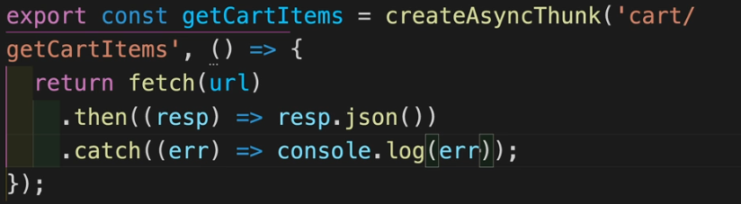

**And now, we need to go to our createSlice function, and go with another parameter, after reducers, with the name extraReducers.**

**This extraReducers operates with lifecycle actions ( The lifecycles of a promise are PENDING, FULLFILLED AND REJECTED)**

**So for every function that we will create ( in this case we created only one, the getCartItems function from the above picture), we will have to define the functionality for each lifecycle.**

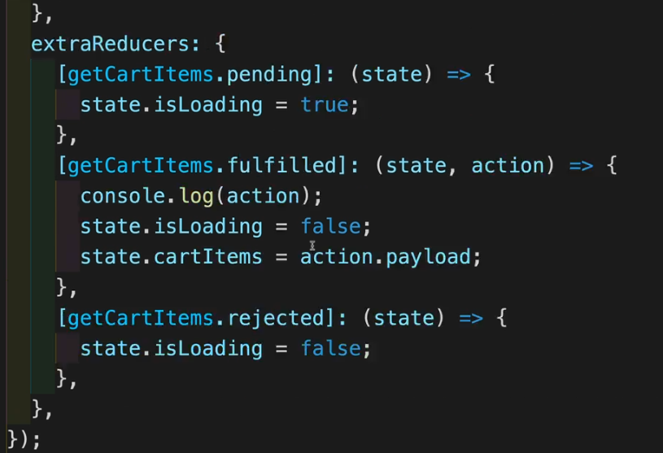

**So, for our function of fetching the data from the API. If we are in the pending lifecycle, the cart will be loading. If the fetcing was succesfull, we stop the loading and also notice that we get the data into our list.**

**The data of the fetch can be accesses from the action.payload**

**And ofc, if we have an error, we don’t do some big logic yet, because in this example we used fetch, not axios.**

**Now we go to our App.js. We import the function.**



**And simply call it using the dispatch function.**

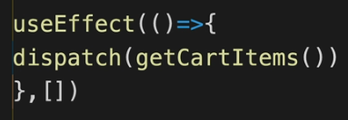

**(420 createAsyncThunk – More Options)**

**This is the modified version of the above function, with the same functionality, just using axios instead of fetch.**

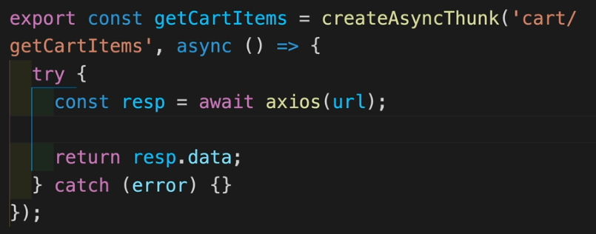

**If we want to pass something from our component, to the createAsyncThunk, we can.**

**Just go to where the dispatch to this function was made and pass a random parameter ( literally)**

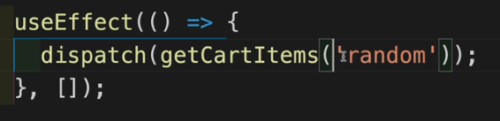

**And just use it in the createAsyncThunk function (name is the parameter)**

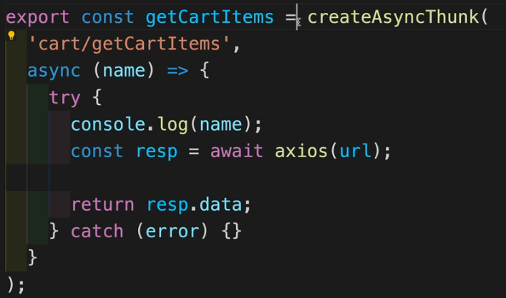 **🡺 this logs “random”**

**Now there is another parameter we can give, and there is a convention to name it thunkAPI.**

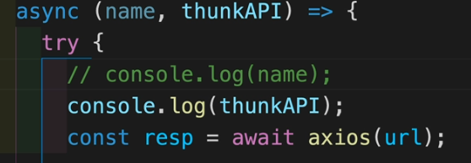

**If we console log this thunkAPI, we get this**

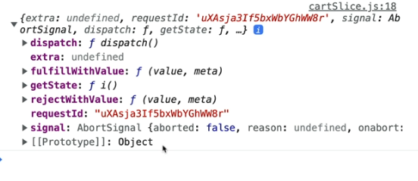

**This is very powerful. We could get the entire state of our application.**



**🡺** 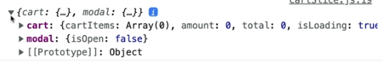

**We could also use dispatch, to dispatch an action/reducer which is not even declared in our current slice**



**And also, since we deal with axios now, we can deal with the errors.**

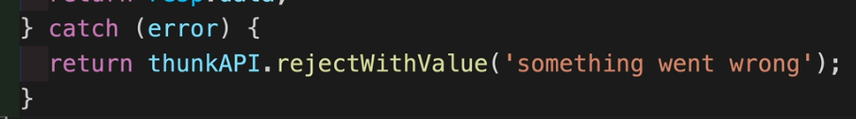

**So from the thunkAPI we call the value rejectWithValue and this value will be passed down to the extraReducers of our slice, the case for the rejected lifecycle of course.**

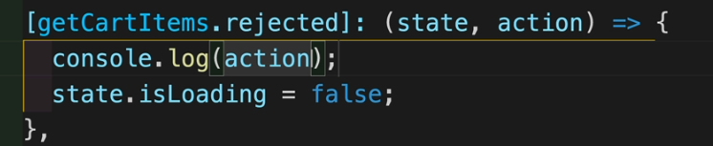

**🡺** 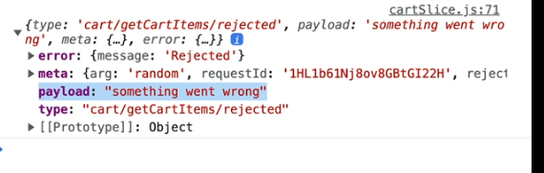

**Also, we know that the error in axios can be accessed from error.response. So we can pass it down instead of a hardcoded message like ,,something went wrong”.**